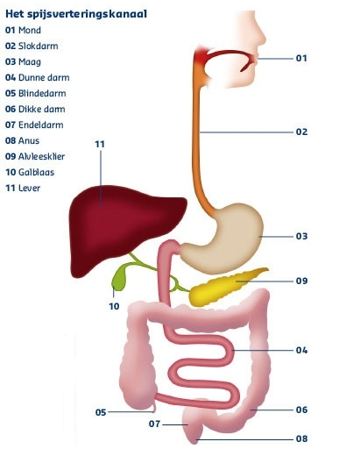

1:

2:

3:

4:

5:

6:

7:

8:

9:

10:

11: